Test Case: tc001_SPX_Dev5_Crear_Requisicion_Spot_Tipo_Cobro_CC
Step 1 - Enter username and password and click to button Enter : Credentials Entered
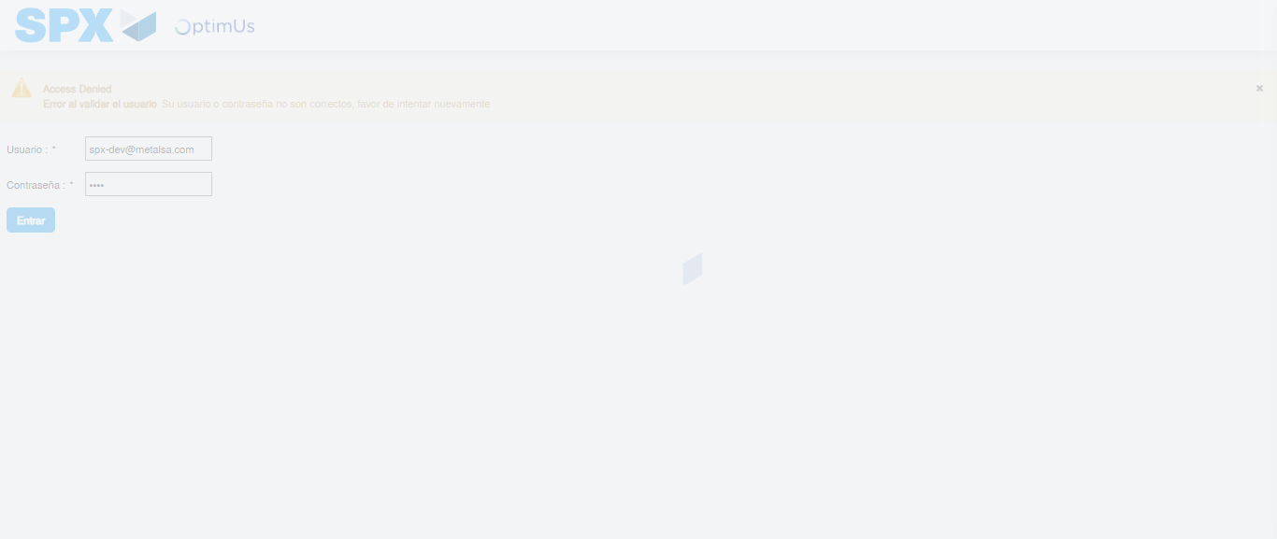Image file-name: QC_Testing-tc001_SPX_Dev5_Crear_Requisicion_Spot_Tipo_Cobro_CC-1784568745085

Step 2 - Select to UEN and Access to Spot Buy Requisitions : UEN Correctly selected and Correct access
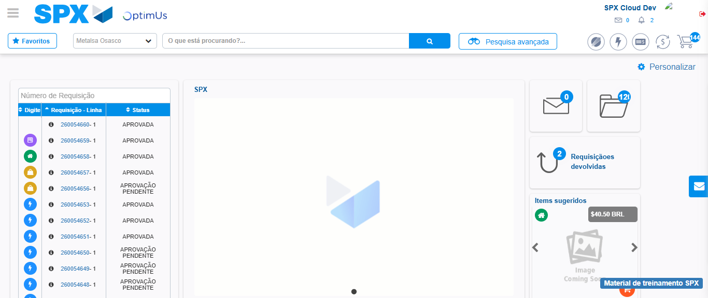Image file-name: QC_Testing-tc001_SPX_Dev5_Crear_Requisicion_Spot_Tipo_Cobro_CC-1784568831338

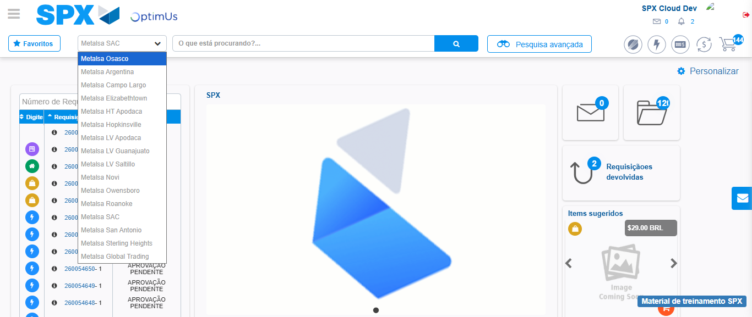Image file-name: QC_Testing-tc001_SPX_Dev5_Crear_Requisicion_Spot_Tipo_Cobro_CC-1784568834295

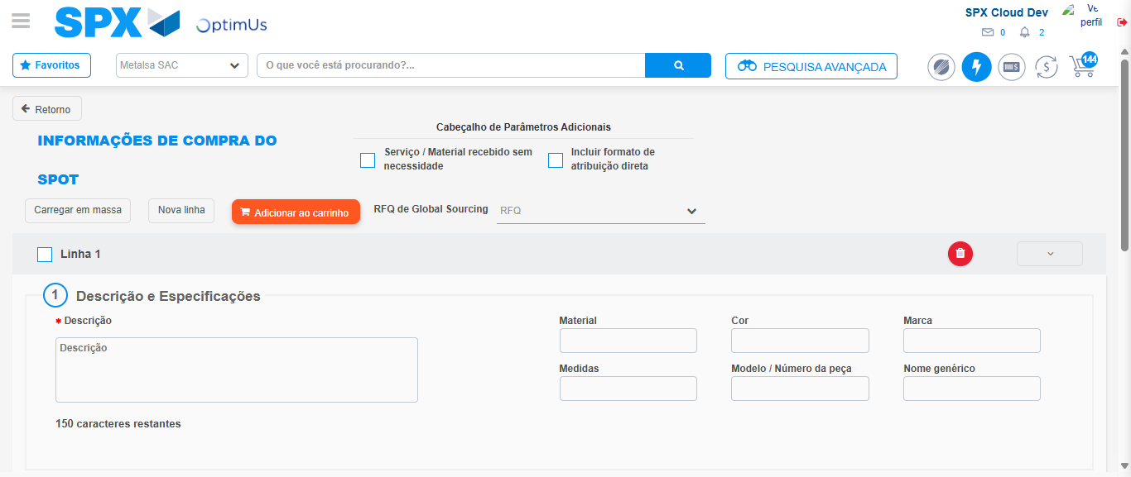Image file-name: QC_Testing-tc001_SPX_Dev5_Crear_Requisicion_Spot_Tipo_Cobro_CC-1784568847035

Step 3 - Data Capture Spot Buy Requisition : Data captured correctly
Image file-name: QC_Testing-tc001_SPX_Dev5_Crear_Requisicion_Spot_Tipo_Cobro_CC-1784568847330

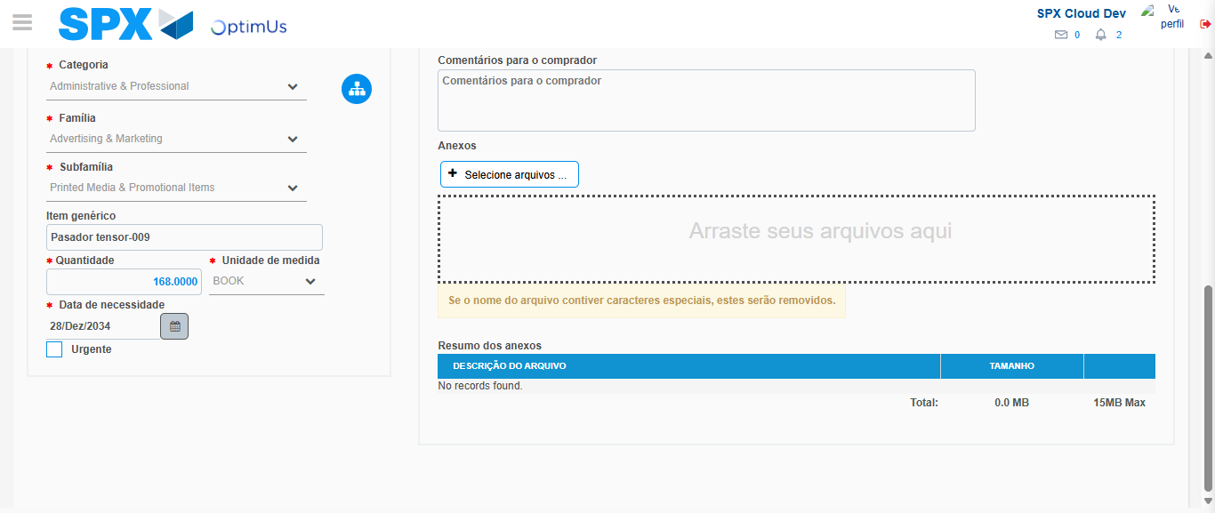Image file-name: QC_Testing-tc001_SPX_Dev5_Crear_Requisicion_Spot_Tipo_Cobro_CC-1784568860449

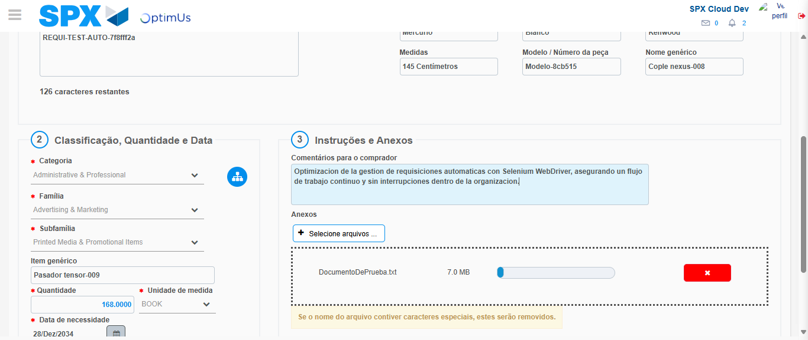Image file-name: QC_Testing-tc001_SPX_Dev5_Crear_Requisicion_Spot_Tipo_Cobro_CC-1784568861451

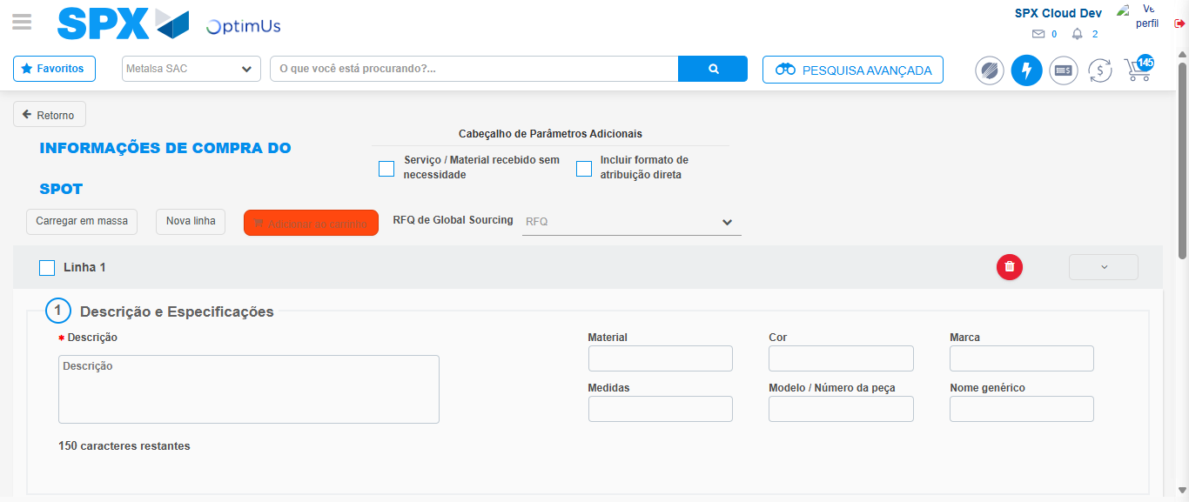Image file-name: QC_Testing-tc001_SPX_Dev5_Crear_Requisicion_Spot_Tipo_Cobro_CC-1784568869421

Step 7 - Return to Main Page SPX : Return to Main Page SPX
Image file-name: QC_Testing-tc001_SPX_Dev5_Crear_Requisicion_Spot_Tipo_Cobro_CC-1784568831338

Image file-name: QC_Testing-tc001_SPX_Dev5_Crear_Requisicion_Spot_Tipo_Cobro_CC-1784568834295

Image file-name: QC_Testing-tc001_SPX_Dev5_Crear_Requisicion_Spot_Tipo_Cobro_CC-1784568847035

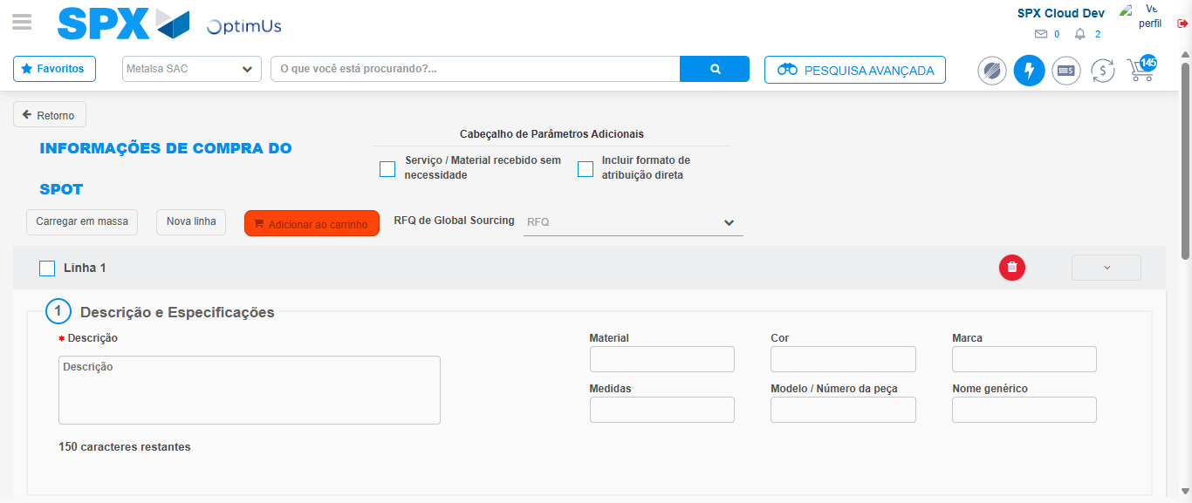Image file-name: QC_Testing-tc001_SPX_Dev5_Crear_Requisicion_Spot_Tipo_Cobro_CC-1784568871676

Image file-name: QC_Testing-tc001_SPX_Dev5_Crear_Requisicion_Spot_Tipo_Cobro_CC-1784568871878

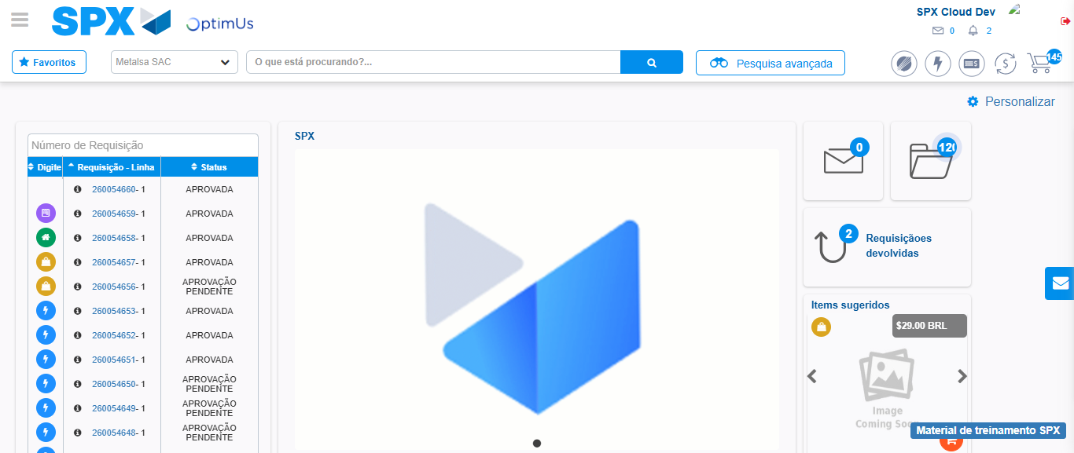Image file-name: QC_Testing-tc001_SPX_Dev5_Crear_Requisicion_Spot_Tipo_Cobro_CC-1784568893059

Step 8 - Log Out : Log Out SPX
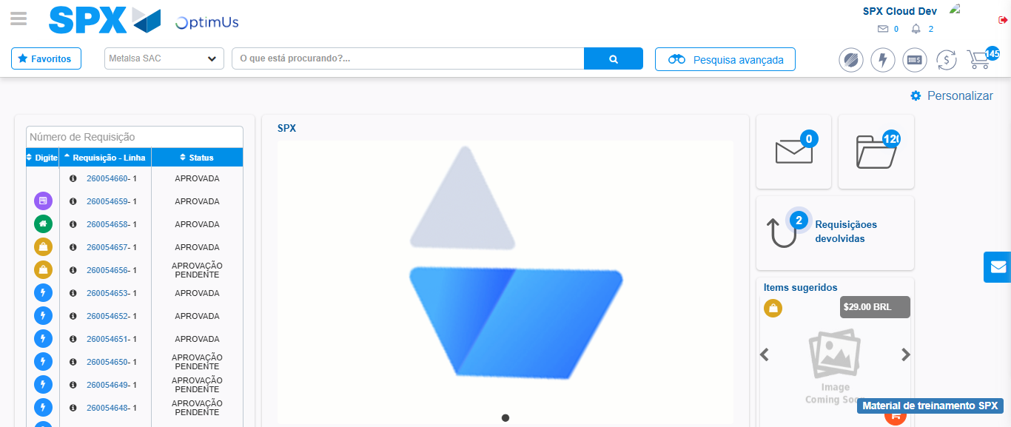Image file-name: QC_Testing-tc001_SPX_Dev5_Crear_Requisicion_Spot_Tipo_Cobro_CC-1784568893429

